Creating Self Hosted Agent for Azure deployment

Step 1. Logon to your azure portal and navigate the project setting.

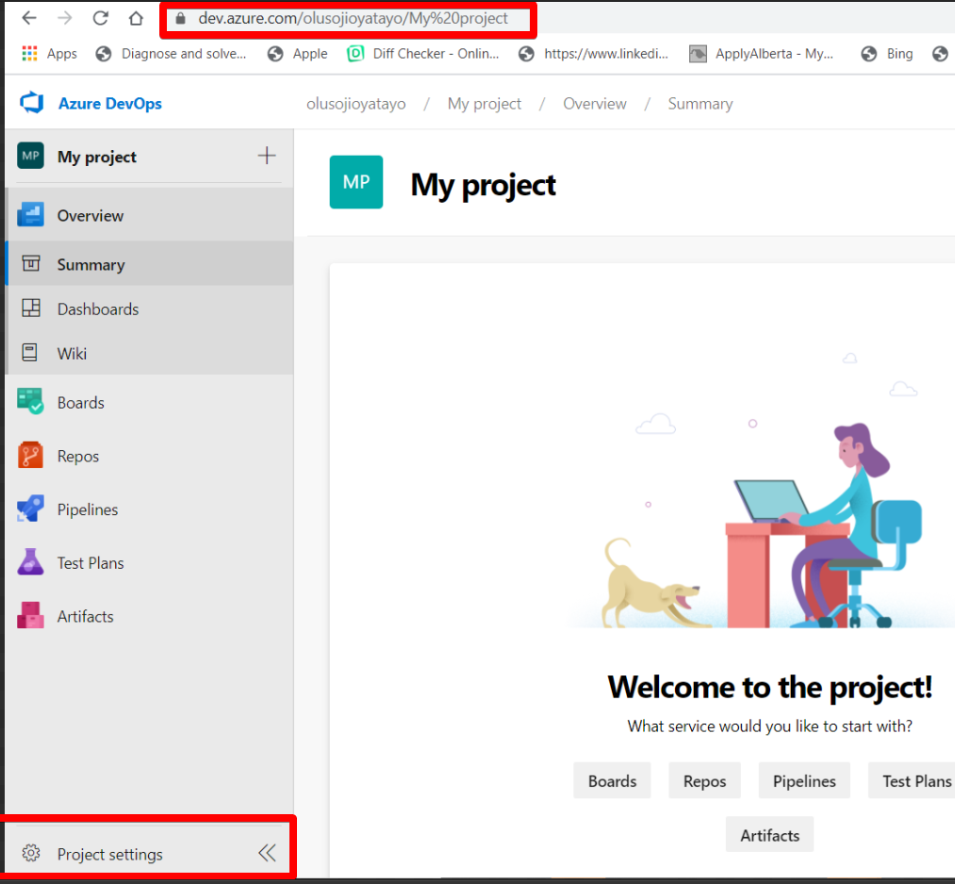

Step 2 From Project settings, under the Pipeline Heading, click Agent Pool. Here you’ll see a list of existing/default Azure Hosted Agent Pool.

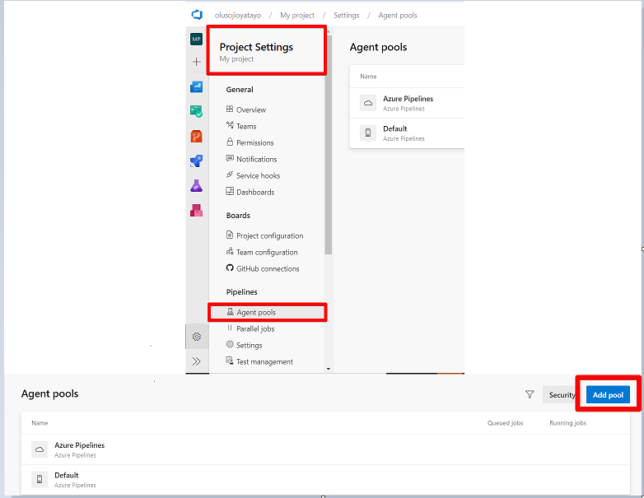

Step 3: Click Add pool at the top right-hand corner to create your own pool of self-hosted agent. From the agent pool type, choose “Self-Host” and give it a desired name by typing in the Name field box. Click create

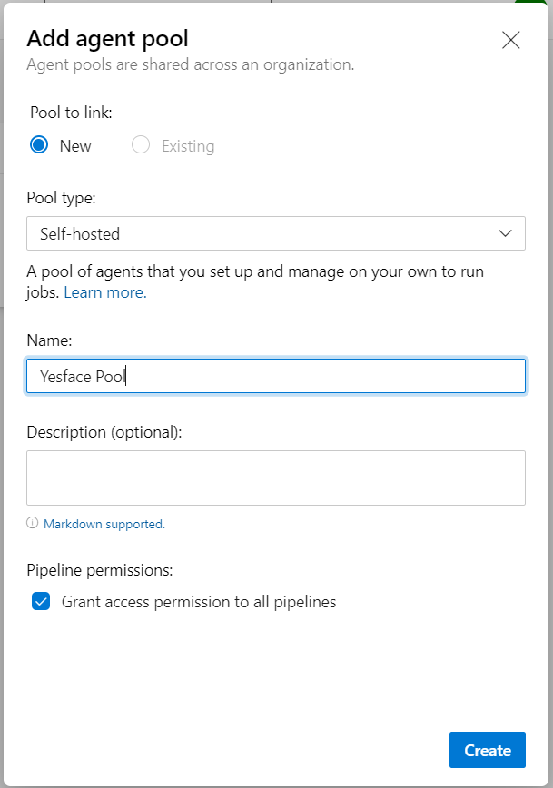

Step 4: Click the newly created agent pool folder and then click “New Agent” at the top right hand corner. Next you’ll have a pop up to download agent configuration script. The various supported OS are displayed as shown below. Downoad the agent script of your desired OS.

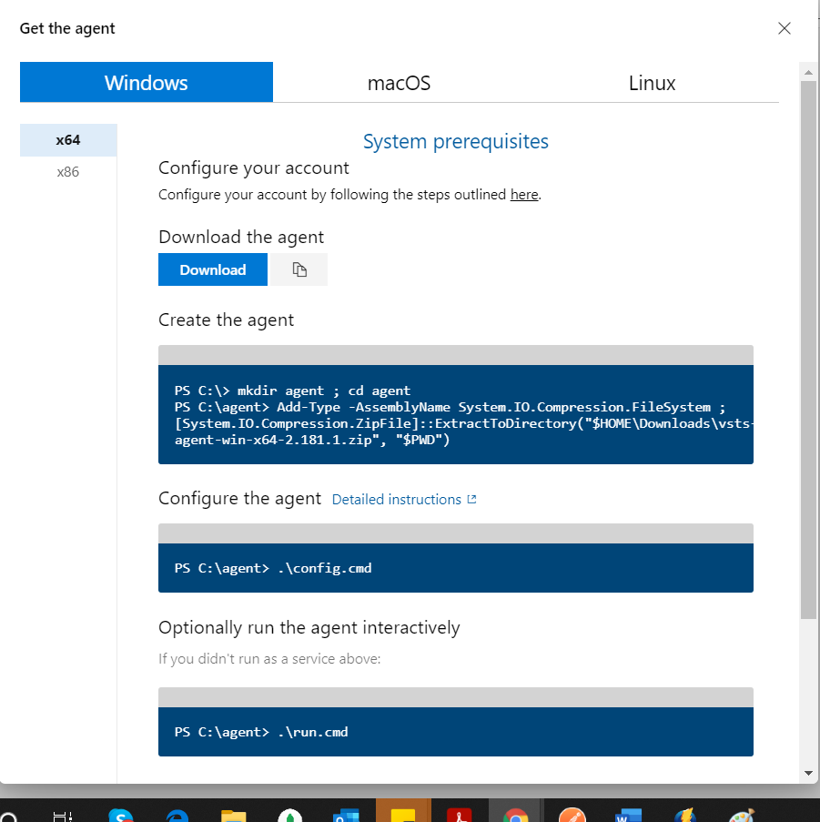

NB: Please take note of the instruction below.

1. Create a folder named “agent” in the root folder or C-drive
2. Extract the downloaded agent script to the agent folder

Step 5: Lunch Power shell as administrator and run the following command.

1. Change directory to the agent folder

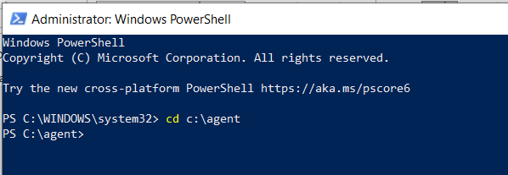

1. Then type the following command

.\config.cmd

1. You will be asked to enter your server url:

Enter your organization azure devops url  
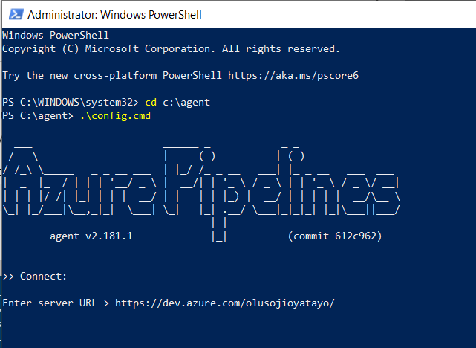

1. Next you are required to supply your Personal Access Token (PAT)

* You can get this from User settings
* 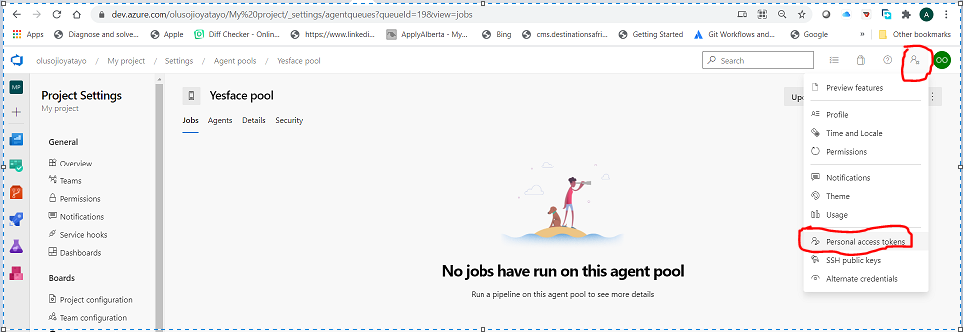
* Click “New Token and give it a name. Choose your desired authorization to which the token should be applicable to or you chose “full”. Then click “Create”

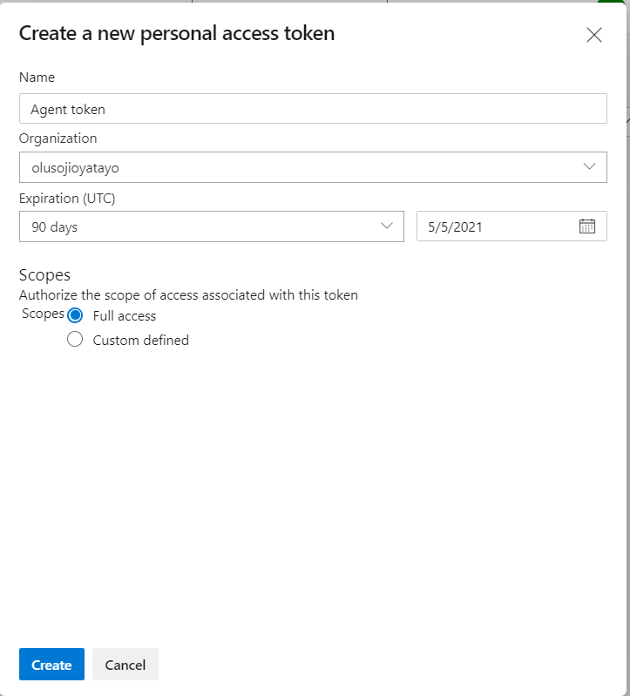

* Copy the token as soon as it created else you will not be able to copy it again

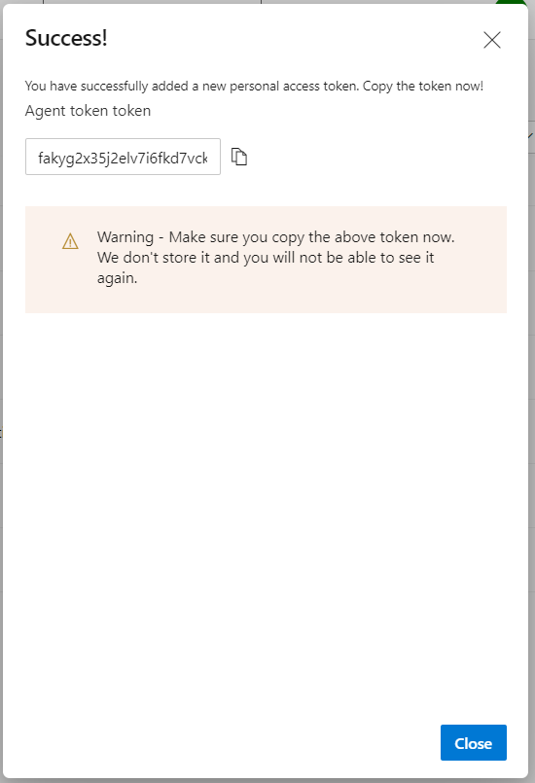

1. Next enter the Agent pool name created on Step 3

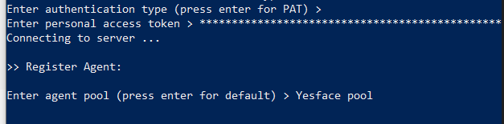

1. Next type your desired agent name  
   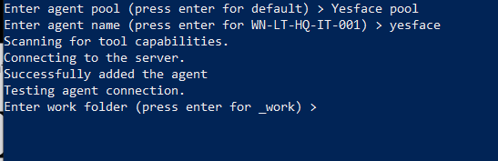
2. Next press “enter” to create work folder with default
3. Press enter not to perform unzip for each task
4. Press “enter” to run agent as a service  
   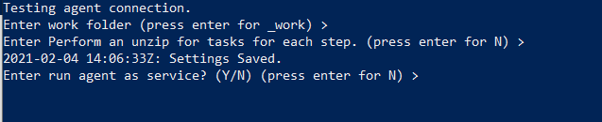
5. Press enter on the next line of command to use NT Authority/Network service if you’re on your company’s network or you system username if you’re running this locally on your system
6. Completed agent is ready

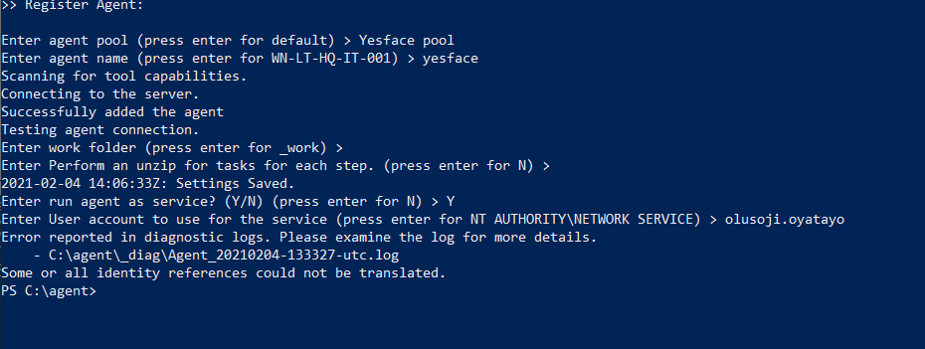

Step 6. Run the following command for agent to start listening for jobs

.\run.cmd

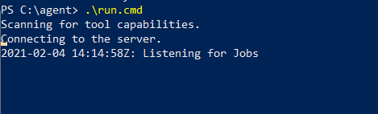

**Thank you**